P6 UNIVERSITY OF DONJA GORICA
REPORT EQUIPMENT

According to the project application and suggestions from coordinators, UDG has prepared detail specification for equipment. Detail specification include description of the item and purpose as well. Specification has been sent coordinator and Agency EACEA for approval.

After approval received, tender procedure has been started. All documentation are available according to request:

- Revision of equipment and specification has been done;

- Prepared Bid Call for equipment / decision of open call

- Distribution of information among IT companies – website, newspaper, email.. Open Call was announced at website of the University of Donja Gorica and in newspaper – “Pobjeda”.

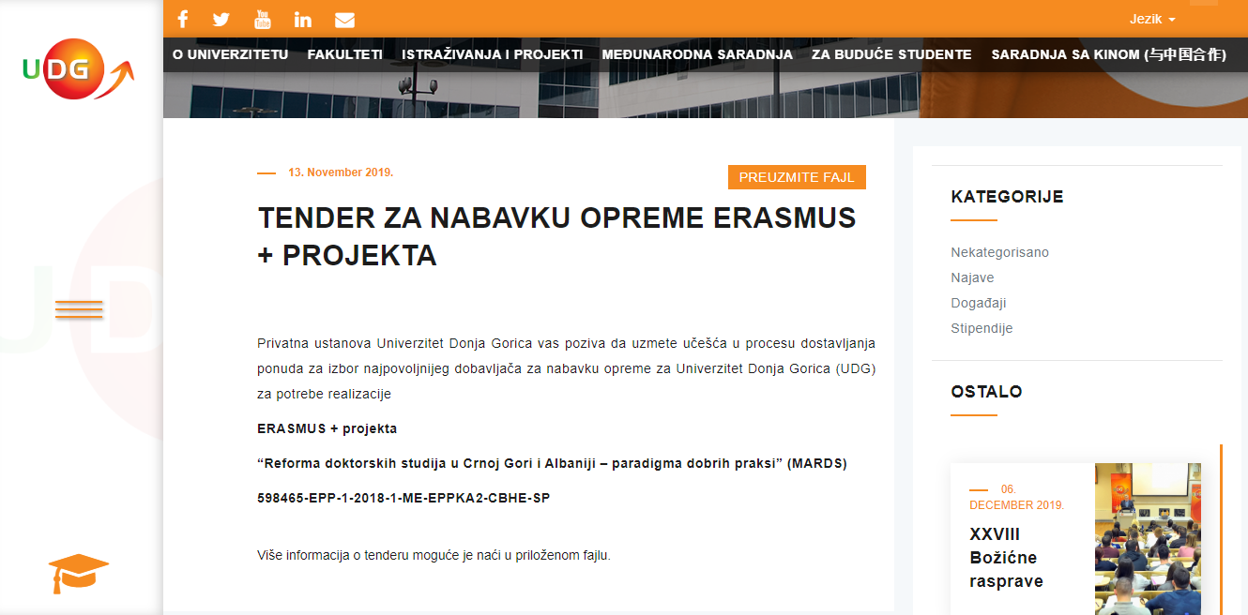



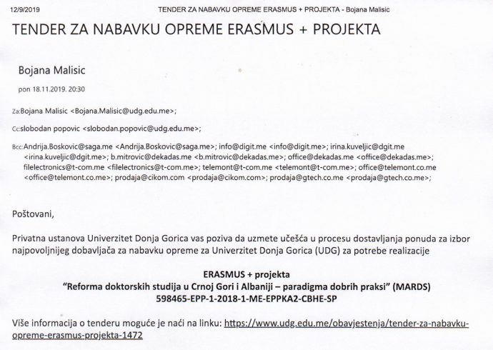

- Preparation of Minutes of Bid opening by Bid opening Committee - Three bids were received by the bid closing, as follows:SAGA doo, Cikom doo and New Page doo.

- Preparation Meeting Minutes on Bid evaluation process by Bid opening Committee / On the basis of the submitted documentation, the Committee for the evaluation of received bids and selection of the best supplier for procurement of technical equipment for the realization evaluated the bid of company ,,SAGA CG doo” from Podgorica as the best one.

- Agreement with SAGA CG signed.

- Photos
