P10 METROPOLITAN TIRANA UNIVERSITY
REPORT EQUIPMENT

According to the project application, MTU has prepared detailed specification for equipment. Detailed specification includes description of the item and purpose as well.
After approval received, procurement procedure has been started. All documentations are available according to request:

- Revision of equipment and specification has been done. The procurement committee has decided in order to start the procedure and ask for offers from different suppliers
- Request for offers has been sent to different suppliers.

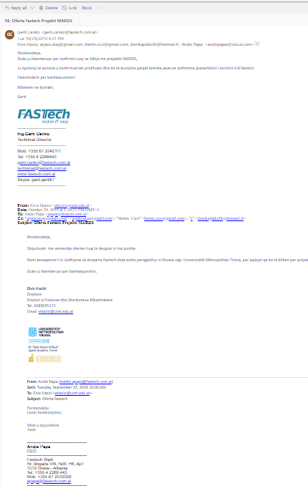
- The offers received from Fastech shpk, Alfa-services shpk and ATD have been evaluated from the procurement committee.
- Based on the documents submitted, the Committee for the evaluation of received offers and selection of the best supplier for procurement of technical equipment for the realization choose the offer of the company “Fastech” on 21.10.2019.
- Notification by e-mail on 29.10.2019 as chosen offer for the MTU.

- Agreement with “FASTECH” SHPK signed on 01th November 2019.

- One room was equipped with MARDS computers.

- MARDS room was equipped with laptop, printer and projector, system video conference, TV.
